**University of Engineering and Technology ,Taxila**

**Department of Computer Engineering**

**Lab Report 06**

**For the Course of DBMS lab**

**Submitted By**:Muhammad Ibrahim (21-CP-26)

**Section:** Omega

**Lab Instructor:**Sir Shahid Ali

**Course Instructor:**Engr.Sana Ziafat

**Date**: 23-02-24.

**Course Title**: DBMS Lab

**DBMS Lab 6 SQL Wild Cards:**

**Examples:**

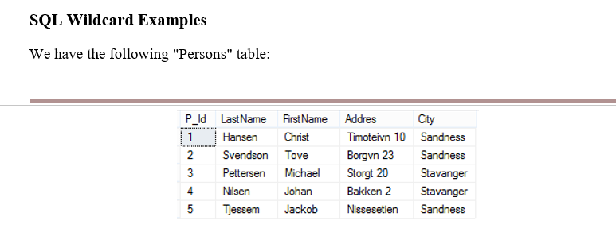

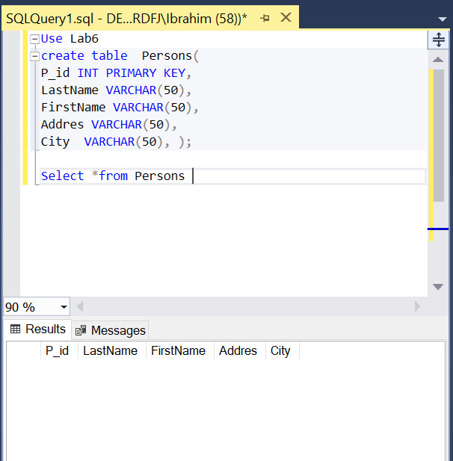

**Code:**

Use Lab6

create table Persons(

P_id INT PRIMARY KEY,

LastName VARCHAR(50),

FirstName VARCHAR(50),

Addres VARCHAR(50),

City VARCHAR(50), );

Select *from Persons

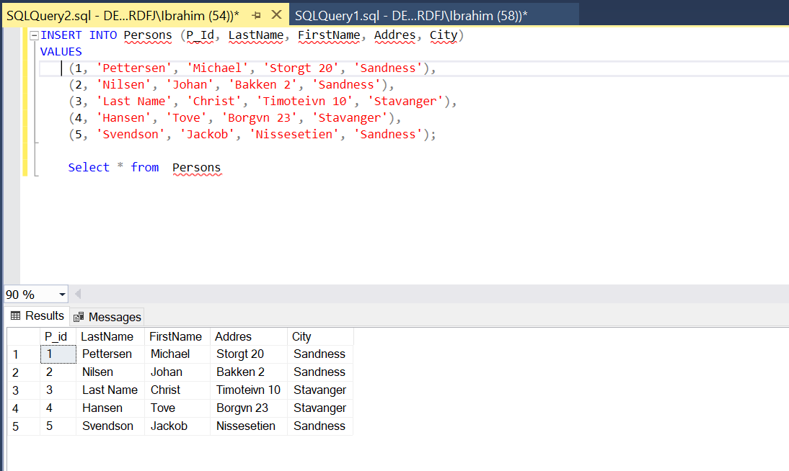

**Code:**

INSERT INTO Persons (P_Id, LastName, FirstName, Addres, City)

VALUES

(1, 'Pettersen', 'Michael', 'Storgt 20', 'Sandness'),

(2, 'Nilsen', 'Johan', 'Bakken 2', 'Sandness'),

(3, 'Last Name', 'Christ', 'Timoteivn 10', 'Stavanger'),

(4, 'Hansen', 'Tove', 'Borgvn 23', 'Stavanger'),

(5, 'Svendson', 'Jackob', 'Nissesetien', 'Sandness');

Select * from Persons

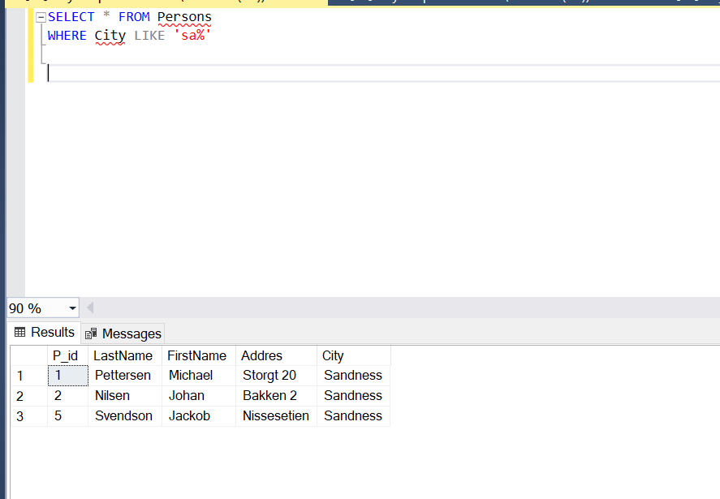

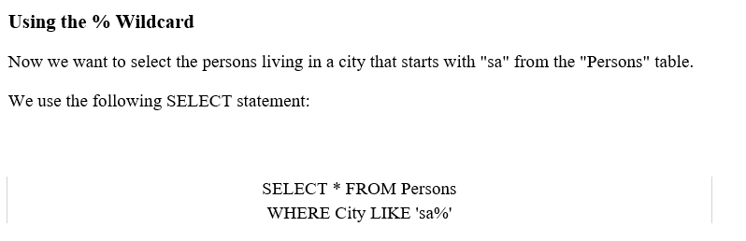

**Code:**

SELECT * FROM Persons

WHERE City LIKE 'sa%'

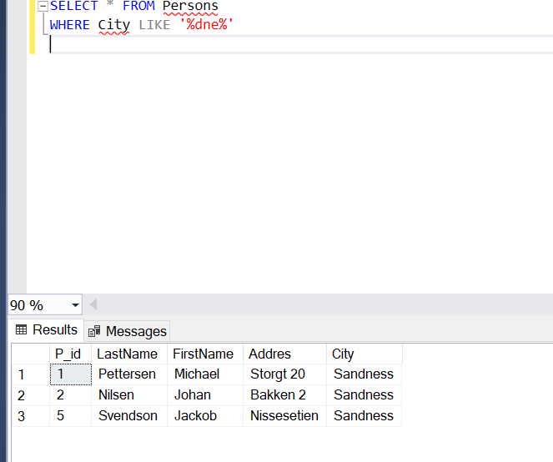

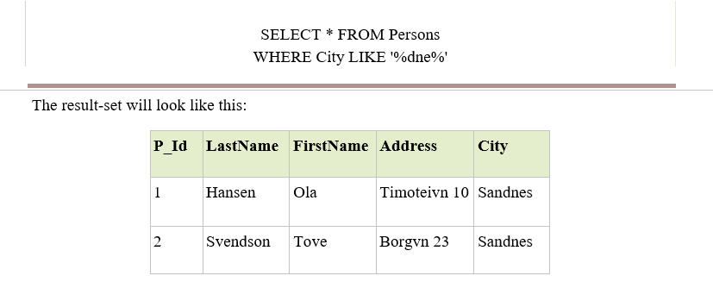

**Code:**

SELECT * FROM Persons

WHERE City LIKE '%dne%'

**Example 2:**

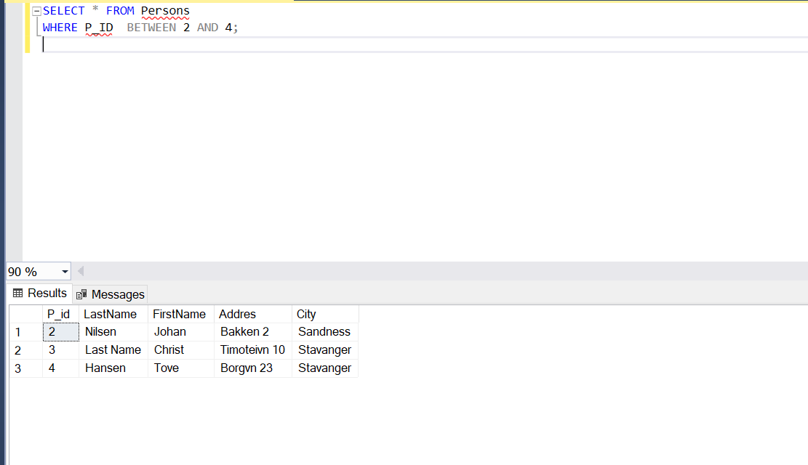

**Code:**

SELECT * FROM Persons

WHERE P_ID BETWEEN 2 AND 4;

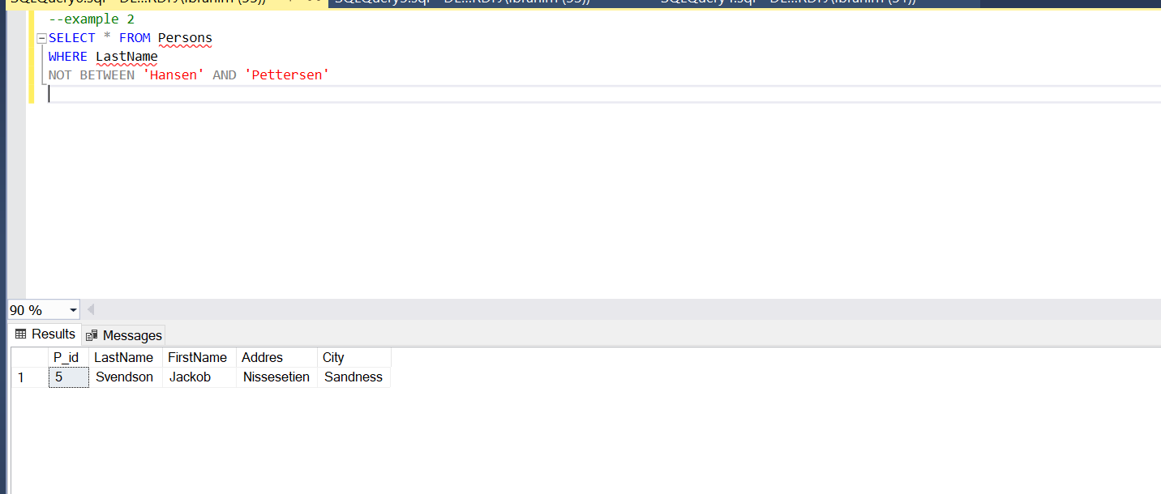

**Code:**

--example 2

SELECT * FROM Persons

WHERE LastName

NOT BETWEEN 'Hansen' AND 'Pettersen'

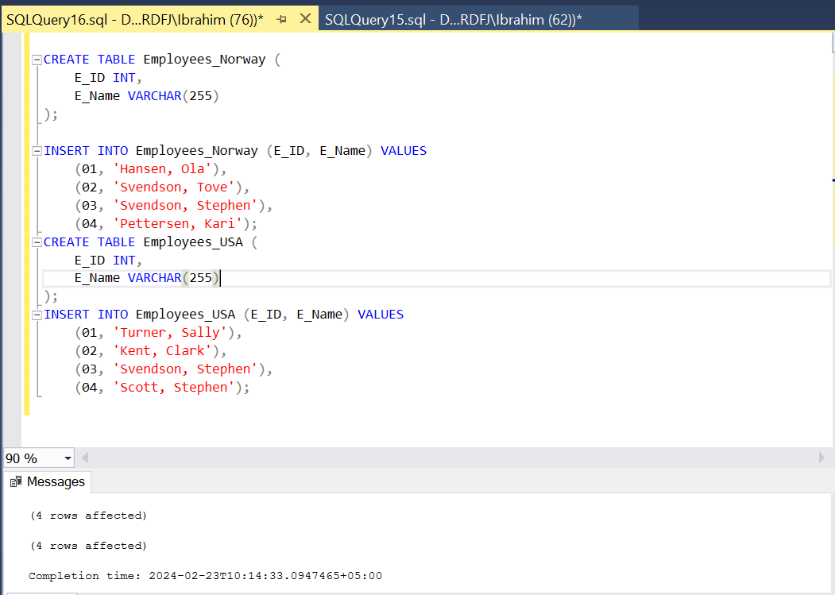

**Code:**

CREATE TABLE Employees_Norway (

E_ID INT,

E_Name VARCHAR(255)

);

INSERT INTO Employees_Norway (E_ID, E_Name) VALUES

(01, 'Hansen, Ola'),

(02, 'Svendson, Tove'),

(03, 'Svendson, Stephen'),

(04, 'Pettersen, Kari');

CREATE TABLE Employees_USA (

E_ID INT,

E_Name VARCHAR(255)

);

INSERT INTO Employees_USA (E_ID, E_Name) VALUES

(01, 'Turner, Sally'),

(02, 'Kent, Clark'),

(03, 'Svendson, Stephen'),

(04, 'Scott, Stephen');

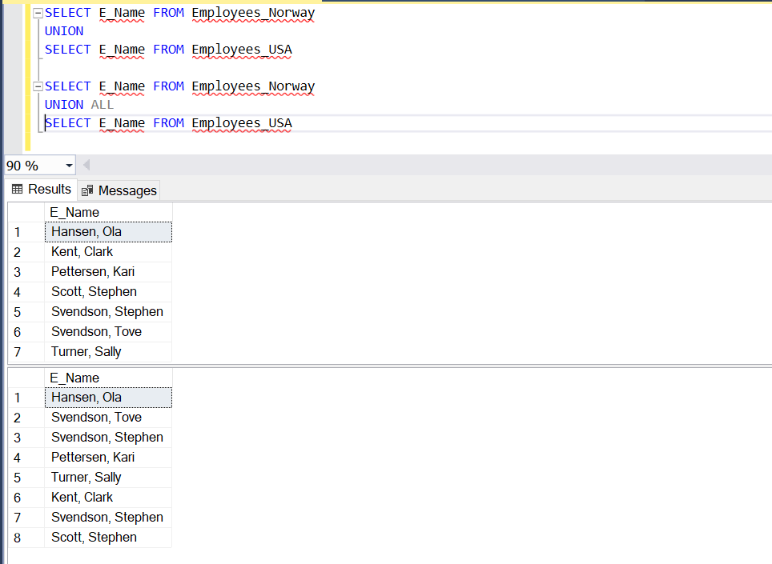

**Code:**

SELECT E_Name FROM Employees_Norway

UNION

SELECT E_Name FROM Employees_USA

SELECT E_Name FROM Employees_Norway

UNION ALL

SELECT E_Name FROM Employees_USA

**Q:NO:1=**

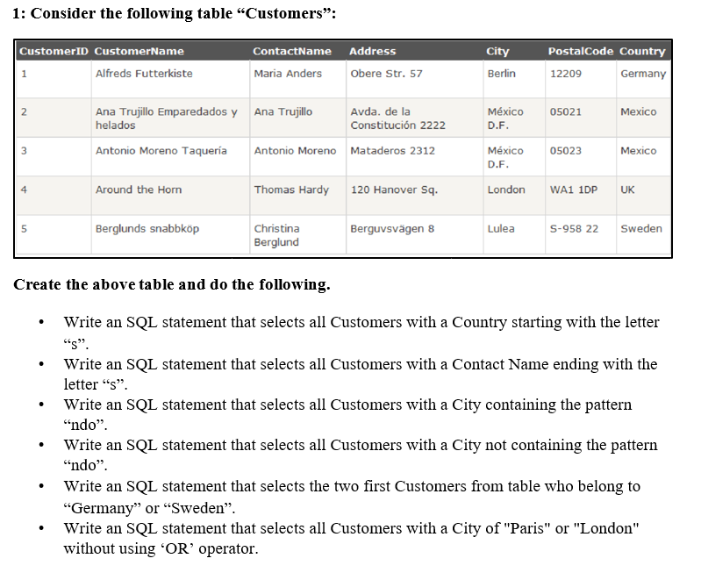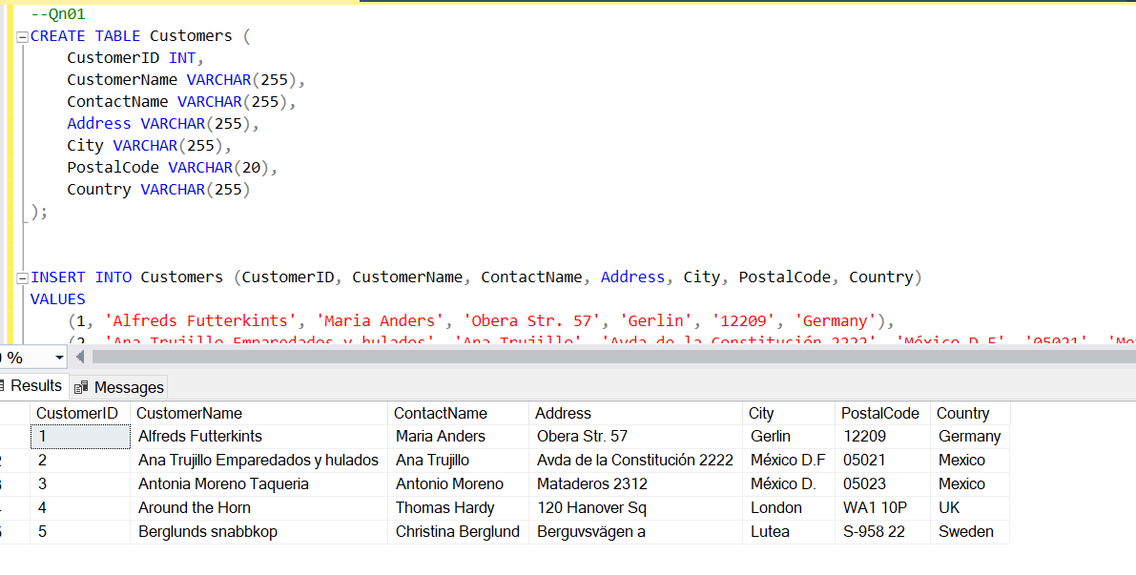

**Code:**

--Qn01

CREATE TABLE Customers (

CustomerID INT,

CustomerName VARCHAR(255),

ContactName VARCHAR(255),

Address VARCHAR(255),

City VARCHAR(255),

PostalCode VARCHAR(20),

Country VARCHAR(255)

);

INSERT INTO Customers (CustomerID, CustomerName, ContactName, Address, City, PostalCode, Country)

VALUES

(1, 'Alfreds Futterkints', 'Maria Anders', 'Obera Str. 57', 'Gerlin', '12209', 'Germany'),

(2, 'Ana Trujillo Emparedados y hulados', 'Ana Trujillo', 'Avda de la Constitución 2222', 'México D.F', '05021', 'Mexico'),

(3, 'Antonia Moreno Taqueria', 'Antonio Moreno', 'Mataderos 2312', 'México D.', '05023', 'Mexico'),

(4, 'Around the Horn', 'Thomas Hardy', '120 Hanover Sq', 'London', 'WA1 10P', 'UK'),

(5, 'Berglunds snabbkop', 'Christina Berglund', 'Berguvsvägen a', 'Lutea', 'S-958 22', 'Sweden');

select * from Customers

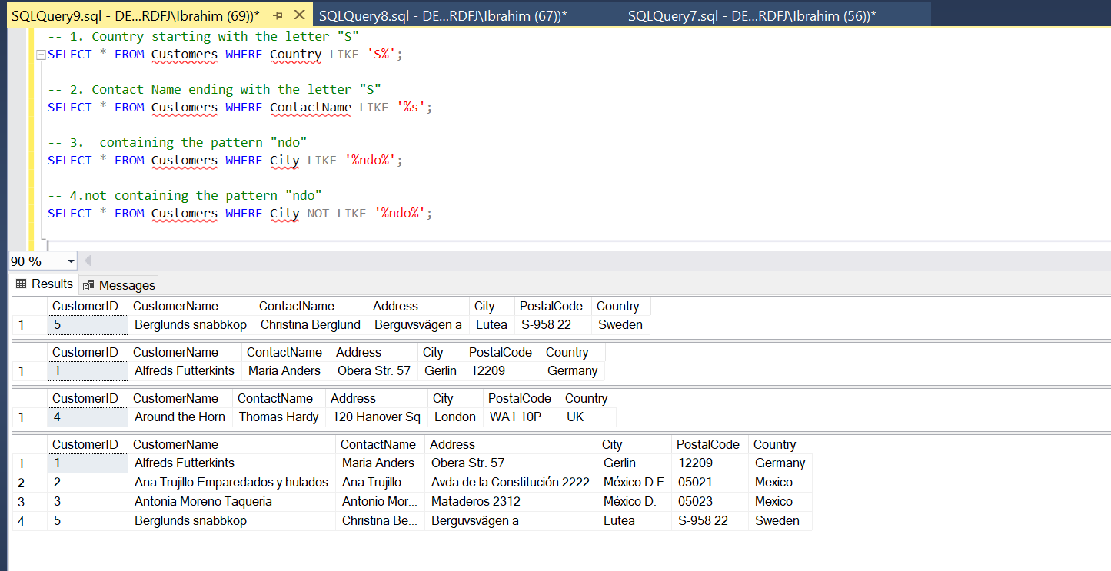

**Code:**

-- 1. Country starting with the letter "S"

SELECT * FROM Customers WHERE Country LIKE 'S%';

-- 2. Contact Name ending with the letter "S"

SELECT * FROM Customers WHERE ContactName LIKE '%s';

-- 3. containing the pattern "ndo"

SELECT * FROM Customers WHERE City LIKE '%ndo%';

-- 4.not containing the pattern "ndo"

SELECT * FROM Customers WHERE City NOT LIKE '%ndo%';

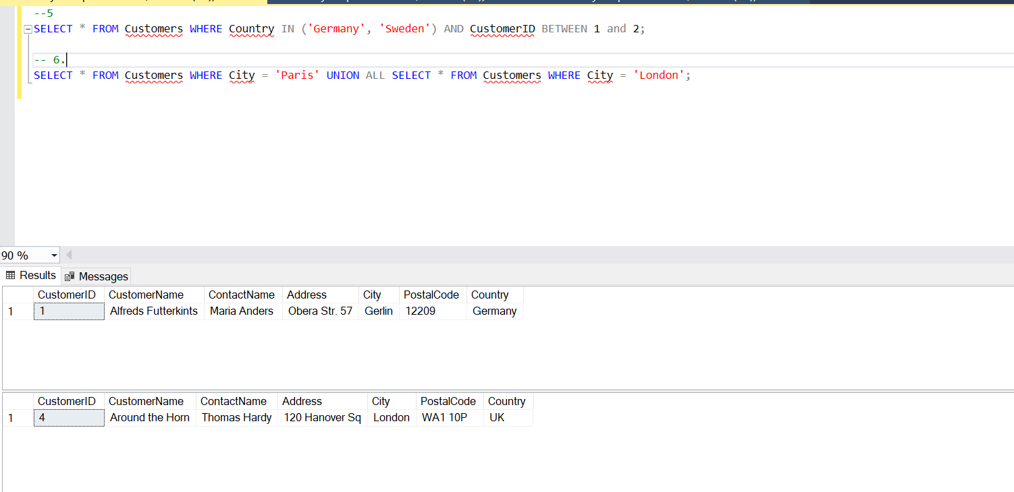

**Code:**

--5

SELECT * FROM Customers WHERE Country IN ('Germany', 'Sweden') AND CustomerID BETWEEN 1 and 2;

-- 6.

SELECT * FROM Customers WHERE City = 'Paris' UNION ALL SELECT * FROM Customers WHERE City = 'London';

**Q:NO:2**

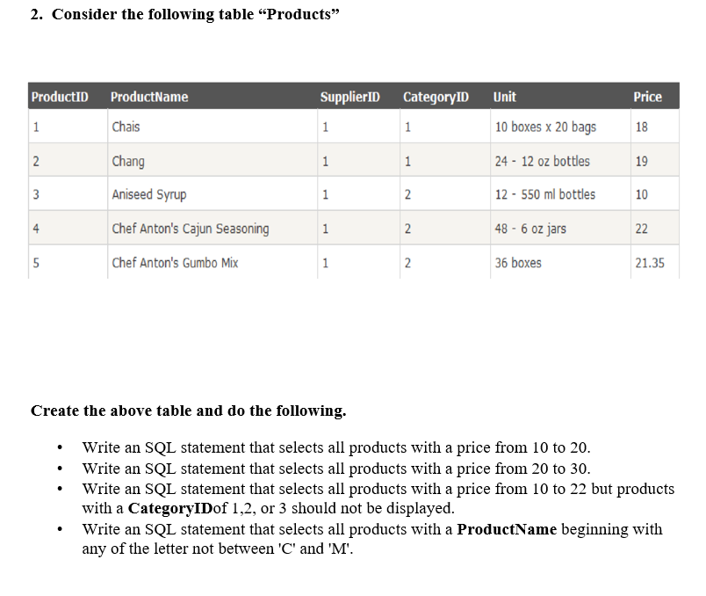

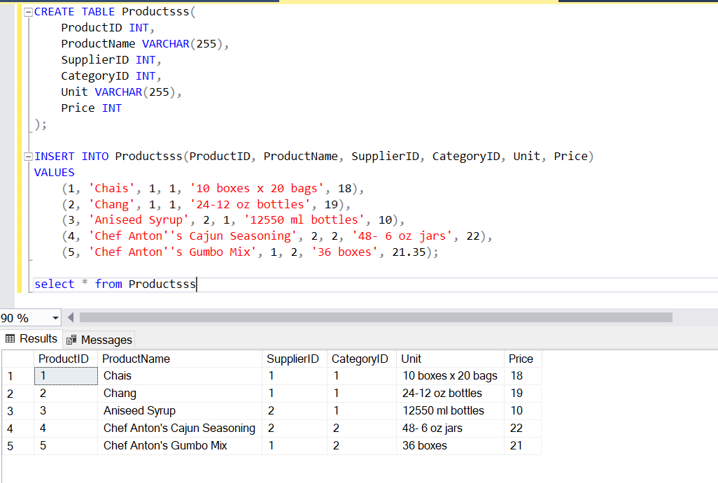

**Code:**

CREATE TABLE Productsss(

ProductID INT,

ProductName VARCHAR(255),

SupplierID INT,

CategoryID INT,

Unit VARCHAR(255),

Price INT

);

INSERT INTO Productsss(ProductID, ProductName, SupplierID, CategoryID, Unit, Price)

VALUES

(1, 'Chais', 1, 1, '10 boxes x 20 bags', 18),

(2, 'Chang', 1, 1, '24-12 oz bottles', 19),

(3, 'Aniseed Syrup', 2, 1, '12550 ml bottles', 10),

(4, 'Chef Anton''s Cajun Seasoning', 2, 2, '48- 6 oz jars', 22),

(5, 'Chef Anton''s Gumbo Mix', 1, 2, '36 boxes', 21.35);

select * from Productsss

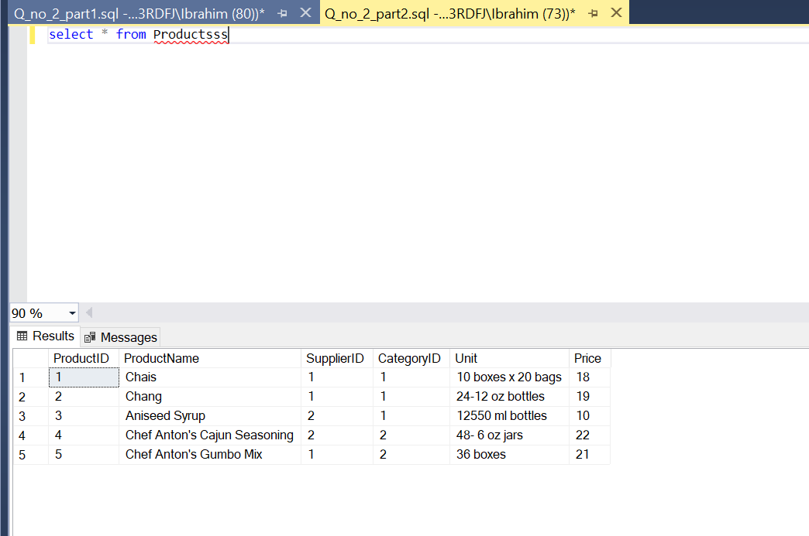

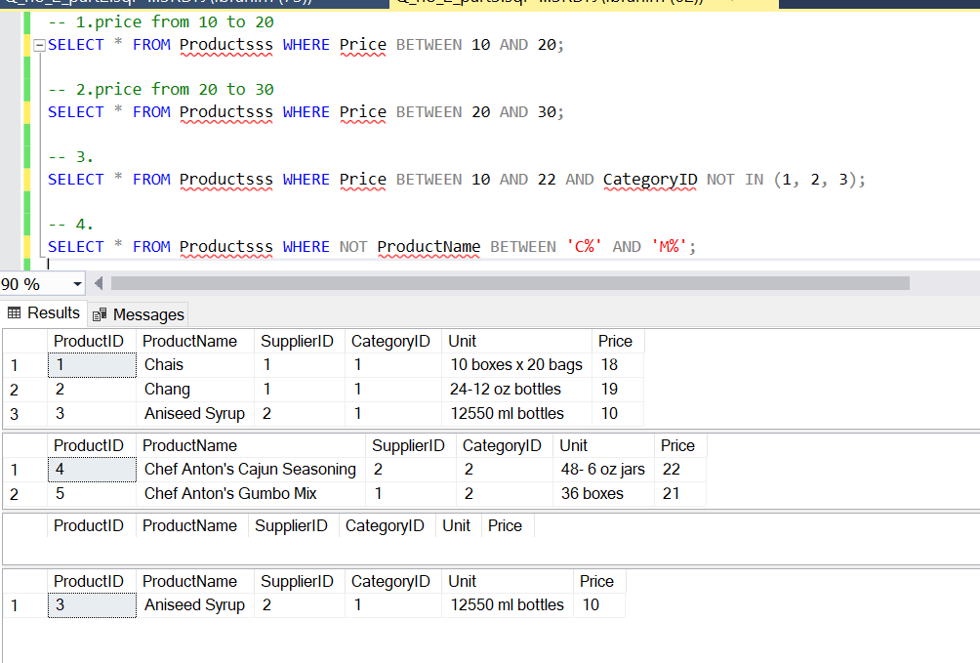

**Code:**

-- 1.price from 10 to 20

SELECT * FROM Productsss WHERE Price BETWEEN 10 AND 20;

-- 2.price from 20 to 30

SELECT * FROM Productsss WHERE Price BETWEEN 20 AND 30;

-- 3.

SELECT * FROM Productsss WHERE Price BETWEEN 10 AND 22 AND CategoryID NOT IN (1, 2, 3);

-- 4.

SELECT * FROM Productsss WHERE NOT ProductName BETWEEN 'C%' AND 'M%';